***Questions***

1. End to End Java Project Development Using Spring Boot
   1. Section 3: Java Project Development Concepts
      1. Heterogonous?
      2. REST?
      3. API?
   2. Section 4, Lecture 19, 2:08s
   3. Section 4, Lecture 24, 0:24s

***Definition***

* Java EE application
* Crud operations
* Entity class
* Controller class (in the Spring MVC world)
* Dependency injection
  + 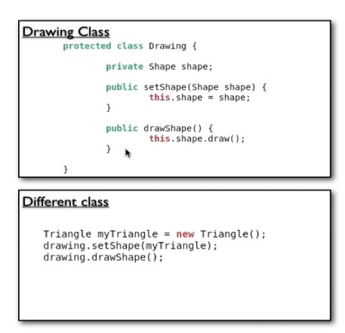
* Spring is a container of beans, factory of beans
  + Multiple objects inside of a spring container. Which the spring container manages the objects, handles its’ instantiation, life cycle, destruction etc…
    - Advantages:
* Factory Pattern, bean factory produces objects?
* Spring XML